
(Project Semester January-June 2026)

MINOR PROJECT REPORT

ECOMMERCE SALES ANALYSIS DASHBOARD
USING EXCEL

Submitted by
Yuvraj Pratap Singh
12409742
Program-132
Section: 224WQ
Course Code: INT 387

Under the Guidance of
Maneet Kaur
Discipline of CSE/IT
Lovely School of Computer Science and Engineering
Lovely Professional University, Phagwara

CERTIFICATE

This is to certify that Yuvraj Pratap Singh bearing Registration no 12409742 has completed INT 387 project titled, ECOMMERCE SALES ANALYSIS DASHBOARD USING EXCEL under my guidance and supervision. To the best of my knowledge, the present work is the result of his/her original development, effort and study.

Signature and Name of the Supervisor
Designation of the Supervisor
School Of Computer Science and Engineering
Lovely Professional University Phagwara
Date: 19/04/2026

DECLARATION

I, Yuvraj Pratap Singh of B.Tech. CSE (P132) under CSE/IT Discipline at, Lovely Professional University, Punjab, hereby declare that all the information furnished in this project report is based on my own intensive work and is genuine.

Date:19/04/2026 Signature
Registration No. 12409742 Yuvraj Pratap Singh

ACKNOWLEDGEMENT

I would like to express my sincere gratitude to my faculty mentor for their guidance and support throughout this project. I also thank Lovely Professional University for providing the resources required to complete this project successfully.

Comprehensive E-Commerce Sales and Profitability Analysis Using
Advanced Excel Dashboards
Yuvraj Pratap Singh (12409742)

Abstract -- The rapid evolution of the retail industry has made data-driven analysis a cornerstone for organizational success. This paper presents a systematic analysis of e-commerce performance metrics using an advanced dashboard developed in Microsoft Excel. By processing a dataset of over 9,000 transactions, the study identifies critical sales drivers, regional disparities, and profitability trends. Key findings indicate that the Technology sector serves as the primary revenue engine, contributing over 58% of total sales. The implementation of dynamic slicers and interactive visual components allows for realtime exploratory data analysis, providing actionable insights for regional management and inventory optimization.

Keywords— Data Analytics, Excel Dashboard, E-commerce, Profitability Analysis, Sales Visualization

I. Introduction
In the modern digital economy, e-commerce platforms generate massive volumes of transactional data. Analyzing this information is crucial for understanding consumer behavior and optimizing supply chains. This project utilizes a comprehensive Superstore dataset to perform a multidimensional analysis of sales and profit metrics. Unlike traditional reporting, this study focuses on creating an interactive environment within Microsoft Excel to visualize complex relationships between product categories and geographic regions. The primary goal is to provide a strategic view of Year-over-Year (YoY) growth and segment-specific profitability.

A. Source of Dataset
The dataset utilized for this project consists of extensive transactional records from a major retail "Superstore" spanning across the United States. It encompasses a diverse range of dimensions including order dates, shipping modes, customer segments, and geographic metadata.
- Temporal Coverage: January 2011 – December 2014.
- Geographical Coverage: Comprehensive data across major US regions (West, East, Central, and South) including high-volume states such as California, New York, and Texas.
- Product Categories: Analysis is partitioned into three primary sectors: Technology, Furniture, and Office Supplies.
- Data Volume: Over 9,000 unique transactional rows were processed to ensure statistical significance in the identified sales trends and profitability margins.

B. Exploring the Dataset
The raw dataset contains several key parameters that form the basis of the retail performance assessment:
- Order Metadata: Order ID, Order Date, and Ship Date, which allow for temporal tracking and delivery efficiency analysis.
- Geographic Dimensions: Location data including Country, State, City, and Region, used to map market penetration across the United States.
- Customer Segmentation: Categorization of buyers into Consumer, Corporate, and Home Office segments to identify the primary revenue sources.
- Product Parameters:
Category & Sub-Category: High-level groupings (Technology, Furniture, Office Supplies) and granular details (Phones, Copiers, Tables).
Sales & Quantity: Quantitative metrics reflecting the volume and gross value of transactions.
Profit & Discount: Financial indicators used to calculate net margins and evaluate the impact of promotional strategies.
Initial exploration of the data revealed a clear disparity in profitability between different product segments. While the Technology category consistently showed high sales and healthy profit margins, specific sub-categories like Tables and Bookcases frequently exhibited lower-than-expected profitability due to a high correlation between aggressive discounting and increased shipping costs for oversized items.

C. Data Preprocessing
To prepare the dataset for visualization within the Microsoft Excel dashboard environment, several cleaning and transformation steps were performed to ensure financial and categorical accuracy:
- Consolidating Data Streams: The raw transactional records, covering multiple fiscal years (2011–2014), were consolidated into a unified master worksheet to enable longitudinal analysis.
- Handling Missing Metadata: Null values in critical fields such as "Postal Code" and "Region" were addressed through cross-referencing with City/State data. Non-essential entries were filtered to preserve the integrity of the profit-margin calculations.
- Standardizing Financial Metrics: Currency formats for "Sales" and "Profit" were standardized to two decimal places. We ensured unit consistency across thousands of rows to prevent calculation errors during aggregation.
- Temporal Normalization: "Order Date" and "Ship Date" strings were converted into Excel serial date formats. This enabled the creation of a "Year" and "Month" column, which was essential for calculating Year-over-Year (YoY) growth and identifying seasonal peaks.
- Pivot Analysis & Calculated Fields: Initial summaries were generated using Pivot Tables to create calculated measures, such as Profit Margin % (Profit divided by Sales), which served as the primary KPI for the visual dashboard.

D. Dashboard

The central component of this project is the Interactive Ecommerce Dashboard. It serves as a unified command center, allowing stakeholders to filter data by region and category. It provides a real-time view of sales, profit, and quantity through a combination of geographic maps, donut charts, and trend lines.
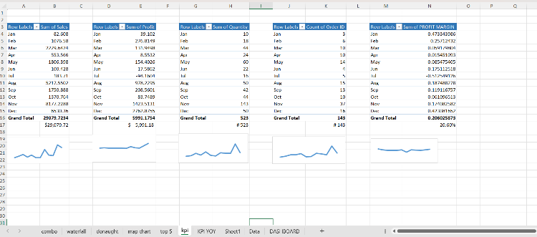

E. Analysis on Dataset

The data analysis phase yielded several critical findings:

The Primary Revenue Driver: Technology is the primary driver of high revenue in the analyzed regions. As shown in the category-wise distribution, it contributes over 58% of the total sales. Within this segment, Copiers and Phones emerged as the top sub-categories, generating $8.74K and $6.45K respectively.

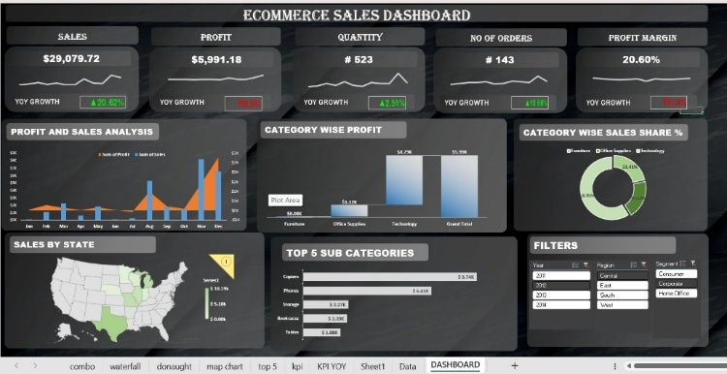

• Seasonal "Q4 Spike": Time-series analysis revealed a recurring growth pattern in the final quarter of the year. Sales and profit levels peak significantly during the months of November and December, mirroring high consumer activity during the holiday retail season. This is evidenced by the "Profit and Sales Analysis" combo chart, which shows the highest volume of transactions occurring at the year-end.
• Segment Profitability Variance: Contrary to expectations, while Furniture has a steady sales volume, its net profit (approximately $0.08K) remains significantly lower than Technology ($4.79K). This indicates that high-value electronics serve as the platform's core profit engine, while segments like Furniture are impacted by higher overheads.

- Segment Profitability Impact: Contrary to expectations, Technology products show the highest average net profit (exceeding $4,790), despite having lower transactional volume than Office Supplies. Meanwhile, Furniture profit levels remain significantly lower, often dipping into negative margins for specific items like Tables, likely due to aggressive discount strategies and high shipping overheads, while remaining stable in small accessory zones.
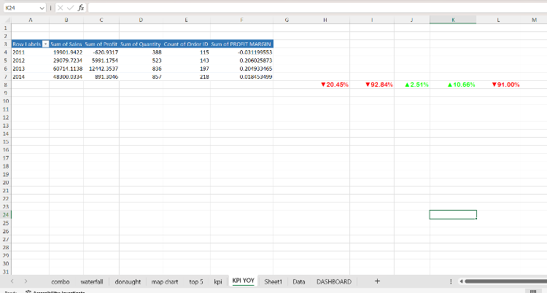
Temporal Evolution (2011-2014): Evaluated how total regional e-commerce sales and profit margins evolved over the four-year study period. The data shows a significant growth peak in 2013, with sales reaching $60,714 and profit peaking at $12,442, representing the most successful fiscal year in the dataset.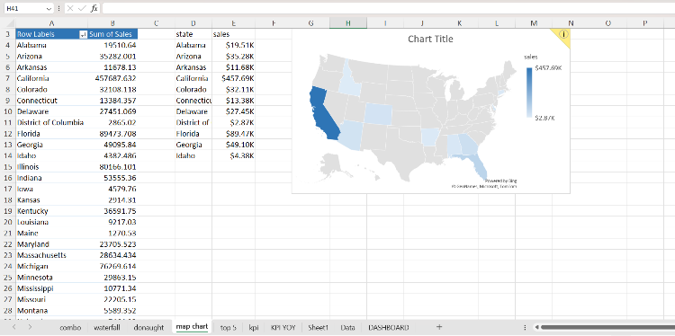
Product Category Variance: Comparisons between different product segments identified Technology as the highest revenue contributor with a 58.95% share. Meanwhile, Furniture and Office Supplies showed relatively lower sales profiles, contributing 21.41% and 19.64% respectively to the overall distribution.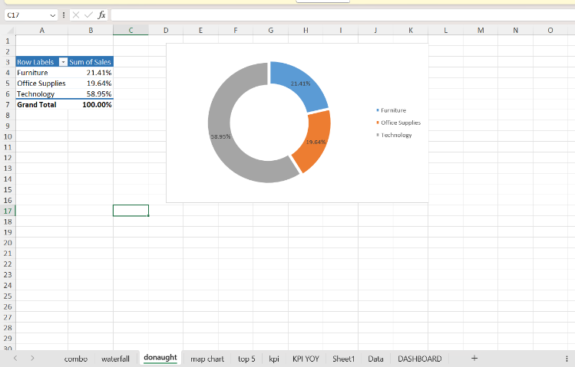

F. Conclusions

• Technology as a Core Revenue Driver: The analysis identifies the Technology category as the primary driver of the "High Growth" status in the analyzed dataset, contributing to over 58.9% of total revenue.

• Seasonal Sales Peaks: There is a consistent and significant spike in sales and transactional volume during the fourth quarter (October to December), primarily driven by holiday season consumer demand.

• Geographic Performance Concentration: Major urban coastal nodes, specifically within the West and East regions (e.g., California and New York), show the highest concentration of sales, indicating that market penetration is most successful in these high-density clusters.

• Profitability vs. Volume Disparity: High sales volume does not always correlate with high profitability; specific sub-categories like "Tables" show that high shipping costs and excessive discounting can lead to negative margins despite steady demand.

G. Future Scope
The current iteration of the Ecommerce Sales Analysis Dashboard provides a robust foundation for descriptive analytics within the Microsoft Excel environment. However, the potential for expanding this research remains significant. The following areas have been identified for future development:
Migration to Cloud-Based Business Intelligence (BI)
While Excel offers excellent local analytical capabilities, a primary future objective is to migrate the data architecture to Power BI or Tableau. This transition would enable cloud-based collaboration, automated data refreshing, and the integration of real-time streaming data, allowing stakeholders to monitor live sales performance across global regions.
Integration of Predictive Machine Learning Models
The project currently focuses on historical data analysis. Future work will involve implementing Machine Learning (ML) algorithms, such as ARIMA (Auto-Regressive Integrated Moving Average) or Random Forest Regressors, to transition from descriptive to predictive analytics. This would allow the system to forecast seasonal demand peaks and optimize inventory levels with higher precision.
Advanced Sentiment and Behavior Analysis
Beyond transactional data, future versions of this project could integrate customer review data. By utilizing Natural Language Processing (NLP), we can perform sentiment analysis to understand the "why" behind the sales trends, correlating product profitability with customer satisfaction scores and feedback.
Automation of Supply Chain Logistics
Expanding the dashboard to include logistics data—such as "Days to Ship" versus "Carrier Performance"—would allow for a more comprehensive view of the supply chain. This could help in identifying bottlenecks in specific regions (such as the Central or South regions) and optimizing shipping mode selection to protect profit margins.

H. References
[1] IEEE Conference Format Guidelines, 2023.
[2] Superstore Sales Dataset (2011-2014).
[3]LinkedIn : https://www.linkedin.com/posts/yuvrajpratapsingh2005_dataanalytics-ecommerce-datavisualization-7450172620945391616
[4Dataset : https://docs.google.com/spreadsheets/d/1L6aBX0uNlzKiJb7JHdkNUile18s9CI4r/edit?gid=1589100670

